HematoLogics, Inc.
3161 Elliott Avenue, Suite 200, Seattle, WA 98121 Phone (800) 860-0934 Fax: (206) 223-5550 www.hematologics.com
Case Study: Eosinophilia and Unexpected B-ALL
HematoLogics was contacted by a university medical center concerning a pediatric patient with a listed history of, "recent onset eosinophilia, history of steroids; now on hydroxyurea."

Diagnostic Sample

∆N:™ (Difference from Normal) Flow Cytometry confirmed a 43% eosinophil population and an unexpected abnormal 4.1% B-ALL population. FACS
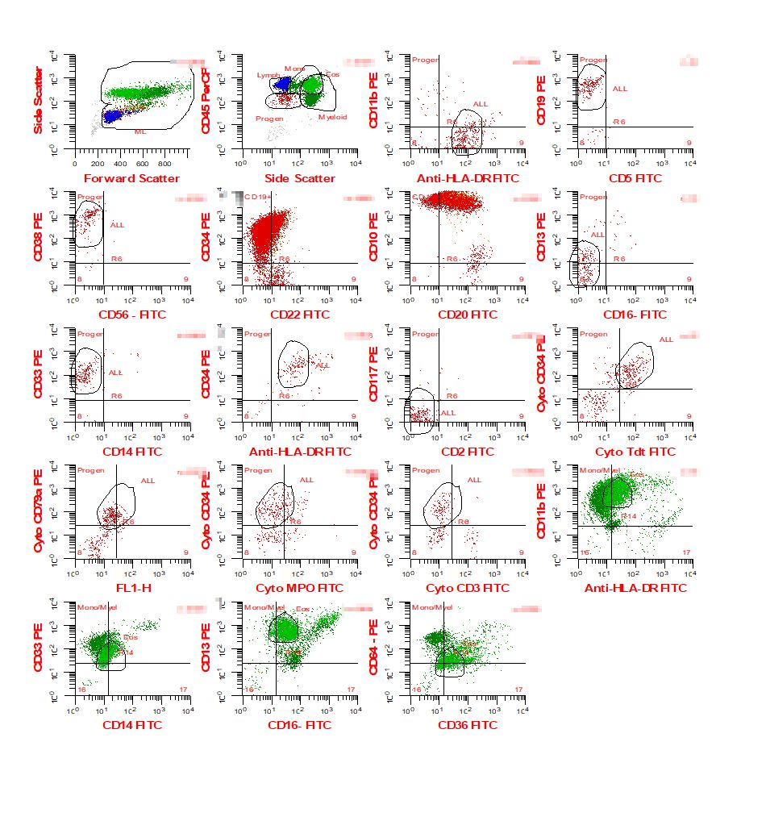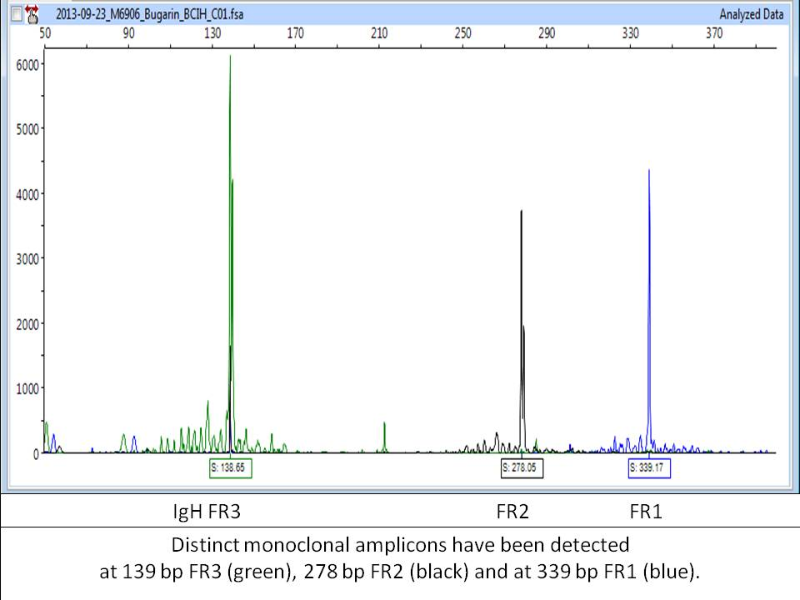
Eos
Cytogenetics from the university was normal, as was FISH at HematoLogics. Fluorescent Activated Cell Sorting (FACS) isolated the B-ALL cells for B-cell gene rearrangement. Results were positive and clonal profiling identified 3 amplicon peaks at bp 139, 278 and 339, providing an identifying fingerprint of the clone. The patient underwent 6 weeks of treatment.

Week 6 Sample (post treatment)

∆N:™ Flow Cytometry identified 66% eosinophils, and 6.1% abnormal lymphoblasts, while again the Cytogenetics and FISH were normal. Clinicians decided on a bone marrow transplant, questioning if both the eosinophils and B-cells were abnormal. FACS was performed to sort CD16 positive Eosinophils and CD19 positive B-cells, followed by SNP/CGH Microarray. It was demonstrated that the Eosinophils were normal and B-cells were abnormal.
FACS
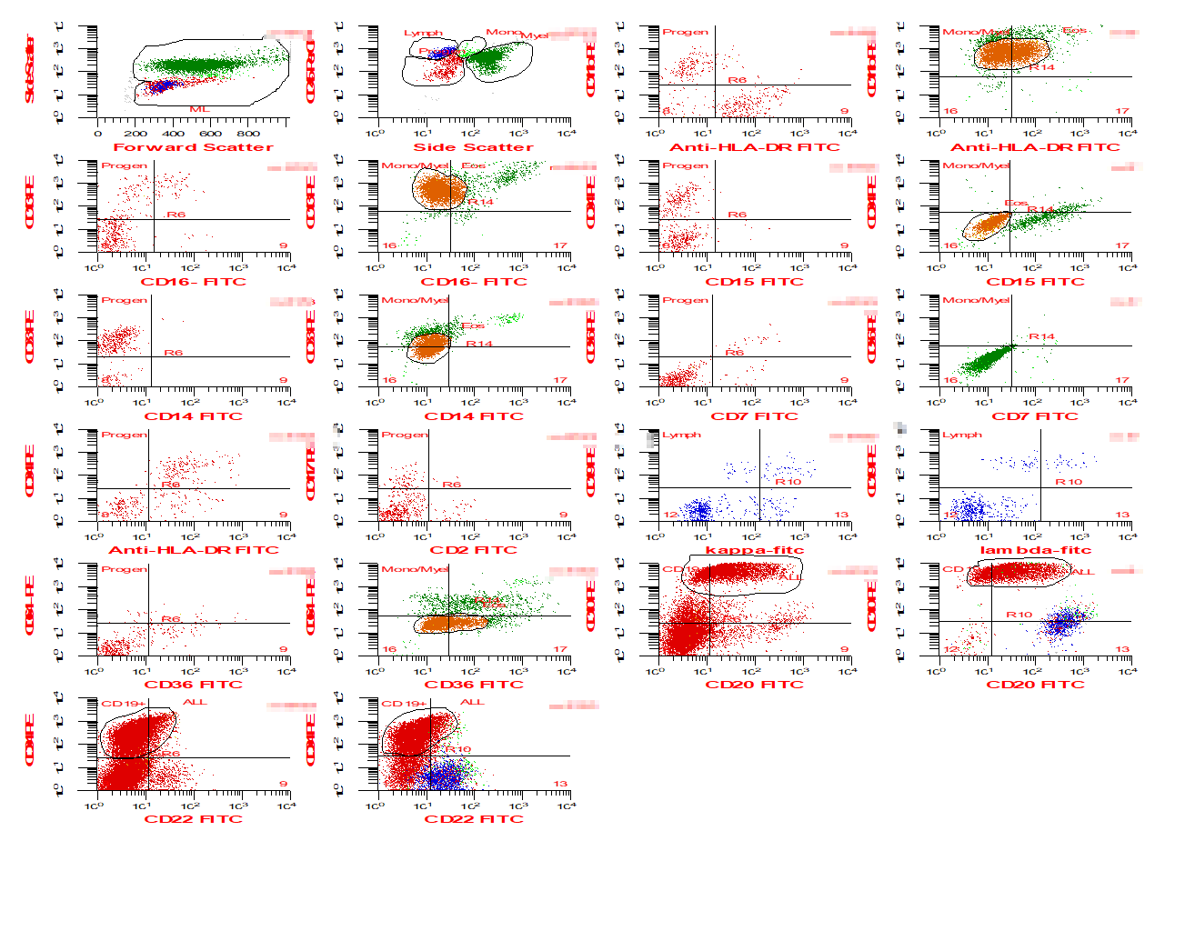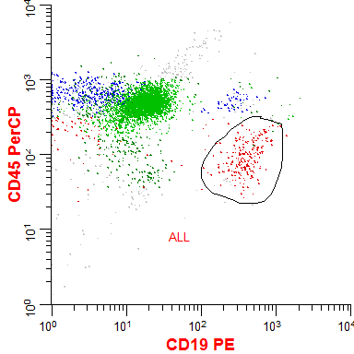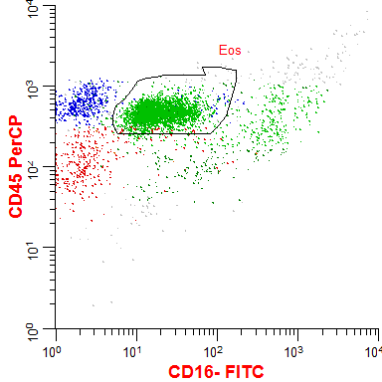
SNP/CGH Microarray Normal Eosinophils

Abnormal
B-cells

Because of the presence of abnormal B-cells pre-transplant, a poor outcome was predicted and the patient was monitored monthly post-transplant and showed no sign of disease for 1.5 years.

1.5 Years Post- Bone Marrow Transplant Sample

∆N:™ Flow Cytometry identifies a 0.01% abnormal B-cell population.

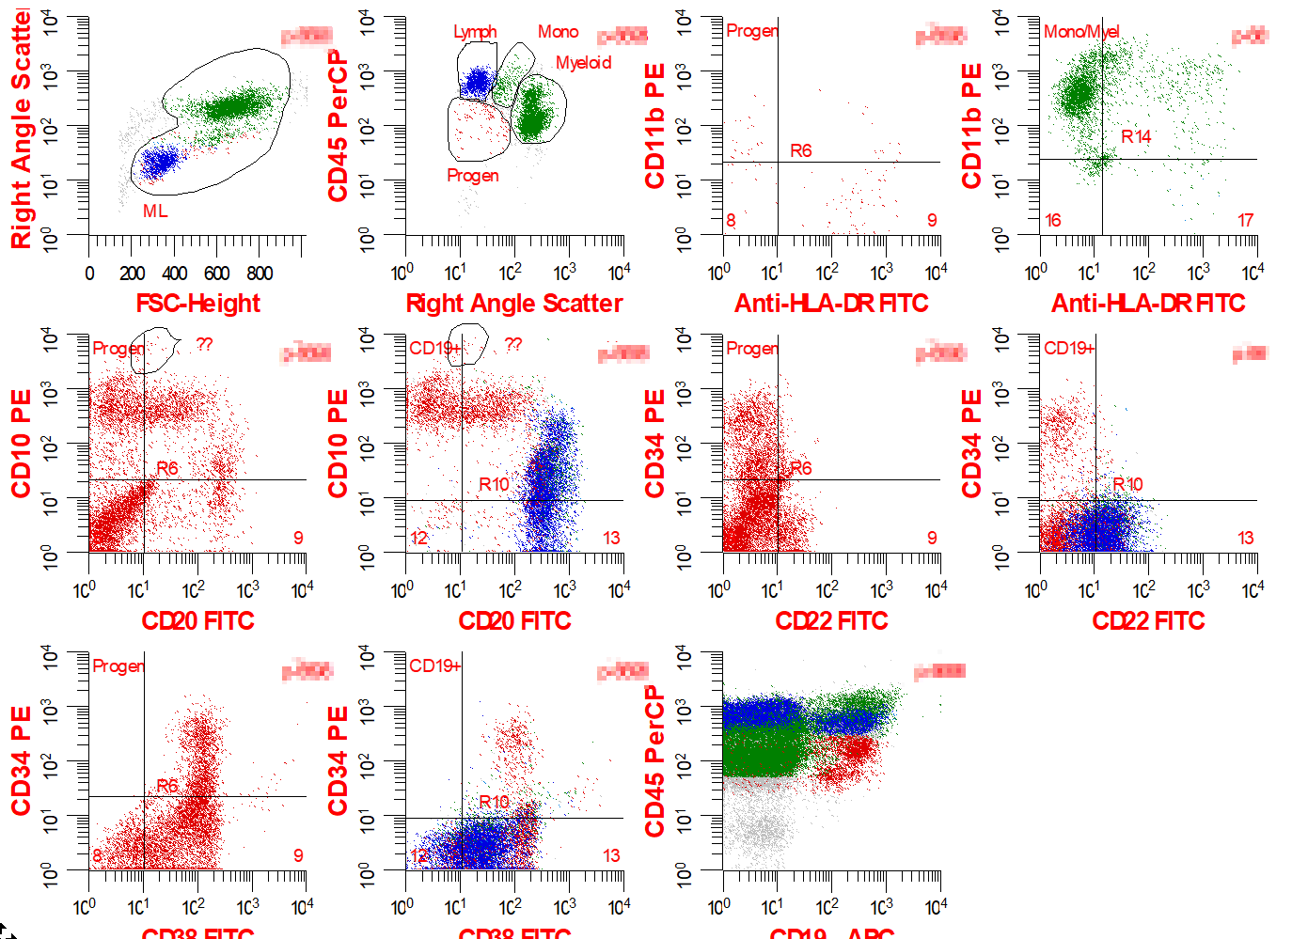

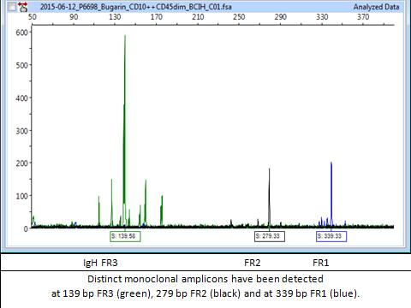
The abnormal B-cell population was sorted using FACS and a B-cell gene rearrangement was performed, showing an identical fingerprint to the original sample, confirming relapse. Treatment was resumed shortly thereafter.

