HematoLogics, Inc.
3161 Elliott Avenue, Suite 200, Seattle, WA 98121 Phone: (800) 860-0934 Fax: (206) 223-5550 www.hematologics.com

BCR-ABL1-Like B-ALL FISH Panel

Philadelphia chromosome-like B-cell acute lymphoblastic leukemia (Ph-like B-ALL) is a high-risk subtype of ALL in children and adults. In contrast to other B-ALL cases, Ph-like B-ALL cases are negative for t(9;22) BCR/ABL rearrangement but confer a similar poor prognostic association. Chromosomal rearrangements involving CRLF2, EPOR, JAK2, PDGFRB have frequently been described in Ph-like B-ALL and can be detected by FISH (Fluorescence in Situ Hybridization).

- The Ph-like B-ALL FISH Panel consists of 4 break-apart probes:
CRLF2, EPOR, JAK2 and PDGFRB
- Turnaround time (TAT): 24 - 48 hours

Probe details:
- CRLF2 (Xp22.33/Yp11.32): Proximal probe in Red; Distal probe in Green.
- EPOR (19p13.2): Distal probe in Red; Proximal probe in Green.
- JAK2 (9p24.1): Distal probe in Red; Proximal probe in Green.
- PDGFRB (5q32): Proximal probe in Red; Distal probe in Green.

The HematoLogics Difference:
- The Ph-like B-ALL FISH Panel can be chosen as a reflex, or up-front testing.
- Only one specimen for ∆N: ™ (Difference from Normal) Flow Cytometry, Cytogenetics and FISH Testing.
- COG certified.
- Result integration with lineage-specific cytogenetic culture optimization.
- Metaphase FISH available.
- Cell Sorting combined with FISH Analysis can be used for Measurable Residual Disease detection and for confirmatory testing in difficult cases.

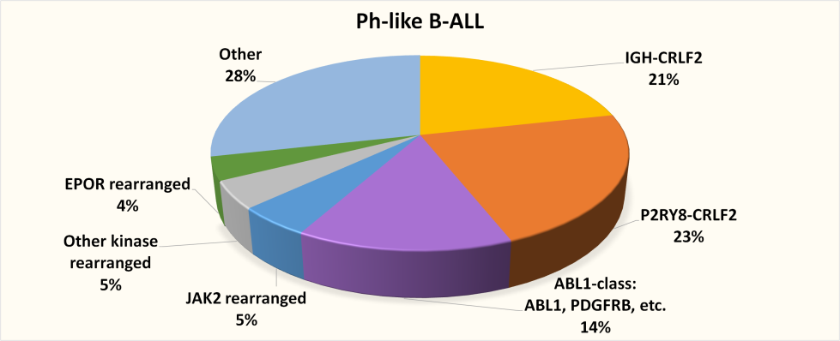
Modified from: Reshmi et al. Blood 2017 129:3352-3361
Best for Your Patient –Best for You

