**HematoLogics, Inc.**

3161 Elliott Avenue, Suite 200, Seattle, WA 98121 Phone (800) 860-0934 Fax: (206) 223-5550 [www.hematologics.com](http://www.hematologics.com)

**Cytogenetics**

**Truly integrated hematologic laboratory services**



* **Fast turn-around time (TAT): < 4 days**
* **High abnormality rate: > 25%**
* **Low failure rate: < 4%**
* **Optimized lineage specific cultures based on individuals’ conditions**
* **Cell pellets preserved for future follow-up testing**
* **Metaphase FISH available for rearrangement confirmation**

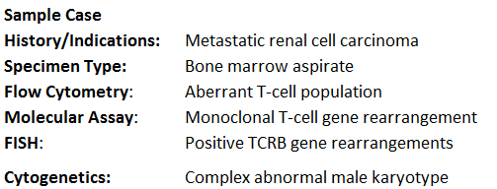

**der(7)inv(7)(p15q34)t(7;10)(q34;q21) der(10)t(7;10)(q34;q21)**

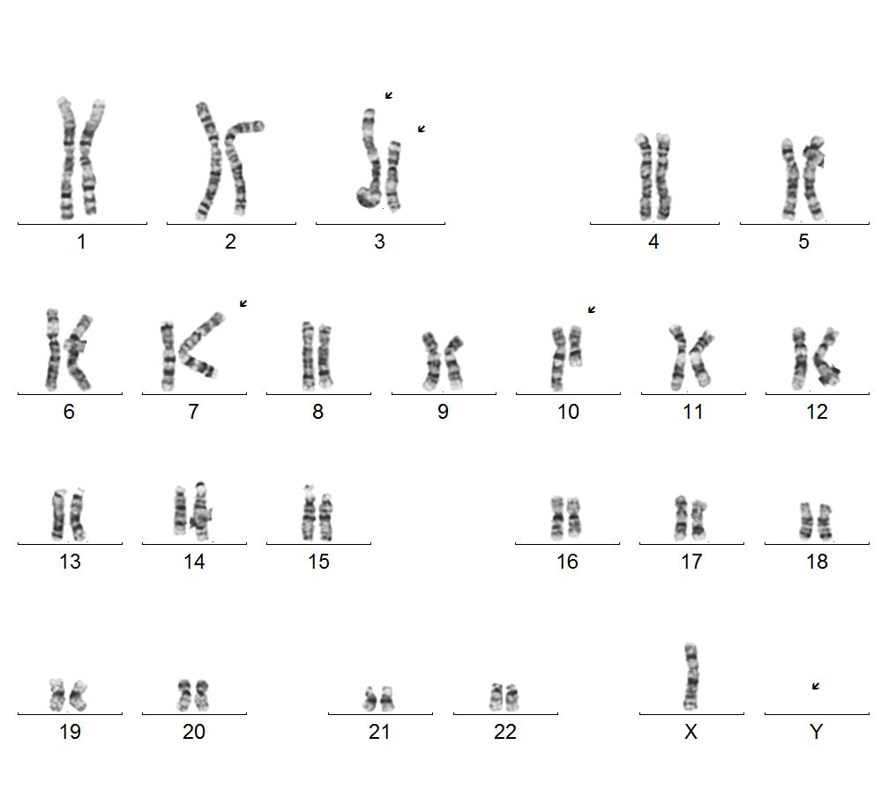

**The key finding variant inv(7) helped to establish diagnosis of a T cell neoplasm.**

**These could ONLY be achieved with:**

* **A reflex T-cell culture set-up triggered by**

**timely internal communication of flow-cytometric data**

* **Superior quality of cytogenetic analysis:**

**High banding resolution and Crystal-Clear chromosome morphology**