**HematoLogics, Inc.**

3161 Elliott Avenue, Suite 200, Seattle, WA 98121 Phone (800) 860-0934 Fax: (206) 223-5550 [www.hematologics.com](http://www.hematologics.com)

**CML like BCR-ABL1 B-ALL Identified by FACS-FISH**

**Hematologics is the only reference labs that routinely runs FACS-FISH on all positive BCR-ABL1 B-ALL cases to rule out CML-like biology**. This determines whether a patient goes to early stem cell transplantation or stays on Tyrosine Kinase Inhibitors long-term.

* BCR-ABL1 t(9;22) now poster child of precision medicine: Treatment tyrosine kinase inhibitors (Imatinib/Gleevec, 2nd/3rd generation) monitored by Quantitative BCR-ABL1 RT-PCR
* BCR-ABL1 (Ph) is not confined to CML but can be found in 5% of pediatric and 25% of adult B-ALL cases.
* While CML responds to chemotherapy with Gleevec, Ph+ ALL has a poor prognosis and leads eventual stem cell transplant.
* CML in lymphoid blast crisis can look like Ph+ ALL and lead to a transplant.
* Ph+ ALL comprised of 2 subpopulations: both Lymphoid B progenitor cells and in CD33+ neutrophils and myeloid cells.
* Chemotherapy and TKI may leave reservoir of Ph+ in other lineages
* New sub-category of CML-like BCR-ABL1-positive ALL

**How is testing performed?**

* Populations of interest are identified by **∆N:™** “Difference from Normal” **Flow Cytometry.**
* **Fluorescent Activated Cell Sorting (FACS)** is used to separate the different cell populations. **Not discernible without flow-cytometric cell sorting**
* Separated populations are then run by **FISH** to identify the abnormalities.

**Why HematoLogics?**

* The diagnostic bone marrow is needed in order to identify this.
* Testing cannot be deferred to a specialty diagnostic center since the technology is not available there and the sample has approximately 72 hours of viability.

**Hovorkova** et al. Blood. 2017 May 18;129(20):277

**Best for Your Patient - Best for You**

**FACS-FISH   
for CML-like BCR-ABL1-positive B-ALL**



**∆N:™ FLOW**

**FACS**



**FISH**

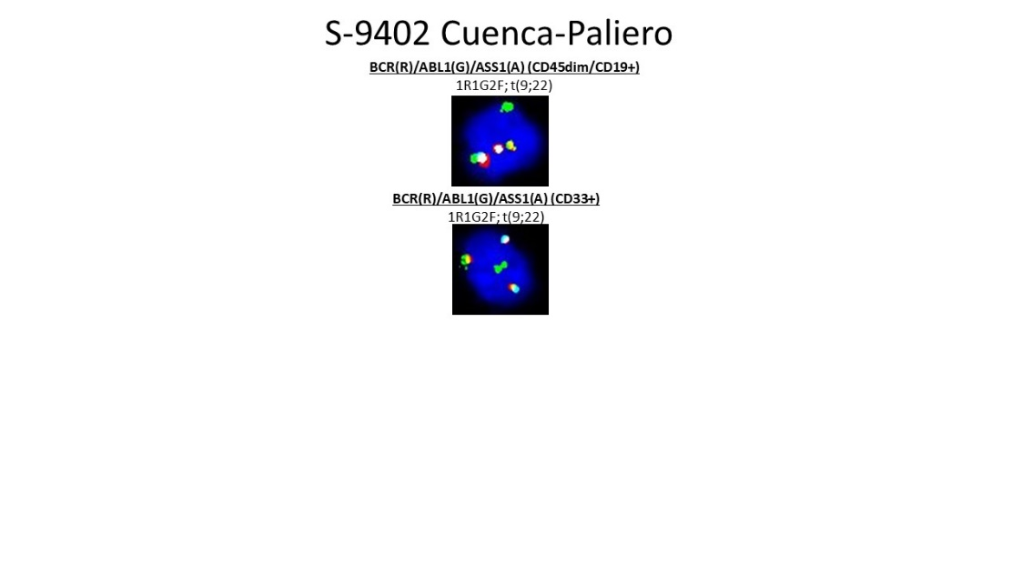

**Hovorkova** et al. Blood. 2017 May 18;129(20):277