HematoLogics
3161 Elliott Avenue, Suite 200, Seattle, WA 98121 Phone: (800) 860‐0934 Fax: (206) 223‐5550 www.hematologics.com
Are you screening for RAM immunophenotype and CBFA2T3‐GLIS2 in pediatric AML?

HematoLogics has identified a unique recurrent Immunophenotype at diagnosis that identifies a high‐risk pediatric AML (RAM)¹
- ∆N:™ (Difference from Normal) Flow Cytometry provides a definitive diagnostic RAM phenotype, which is an independent predictor of poor outcome in pediatric AML
RAM phenotype expresses high intensity CD56 expression, lack of HLA‐DR, dim to negative expression of both CD38 and CD45.
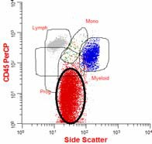
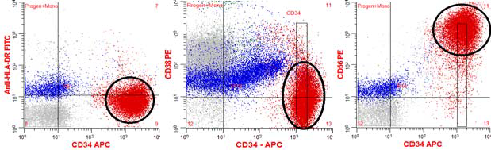
- RAM phenotype can be identified rapidly at diagnosis, allowing clinicians to predict failure before initial therapy, thereby allowing more effective alternative therapies.

- Survival of patients with the RAM phenotype is like, or worse than those with high- risk molecular features and does not respond to standard therapy.
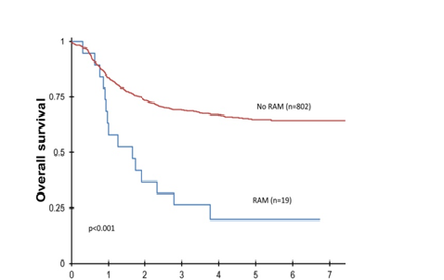
Patients with RAM AML have significantly worse overall survival compared to patients with non‐RAM AML.

No RAM (n=802)
RAM+ (n=19)
- Patients ≤ 5 years old or have AMKL (M7 megakaryoblastic) should be screened and monitored for RAM and CBFA2T3-GLIS22 (both have bad prognoses).
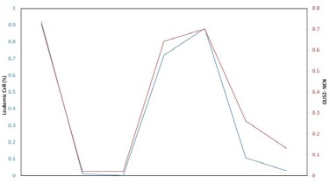
Tracking tumor percentage by both flow and GLIS2 fusion transcripts by RQ‐PCR shows tumor load. (Case Study)

Percent Leukemia by Flow
GLIS2 Normalized Copy Number
- The CBFA2T3 -GLIS2 fusion transcript is a common feature in pediatric AML (M7) in patients having normal cytogenetic findings and confers a poor prognosis.3

- FAB M7 classification might not be poor risk if RAM phenotype patients are considered independently.
Best for Your Patient—Best for You

HematoLogics
3161 Elliott Avenue, Suite 200, Seattle, WA 98121 Phone: (800) 860‐0934 Fax: (206) 223‐5550 www.hematologics.com

SAMPLE MOLECULAR ANALYSIS REPORT

CBFA2T3‐GLIS2 RT‐PCR Results: POSITIVE
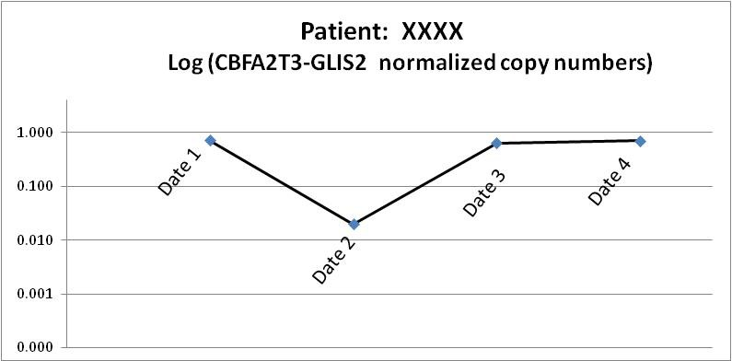
Date | HLID# | Specimen | CBFA2T3‐  GLIS2 NCN | %  Reduction | Log Reduction
Date 1 | HLID1 | BMA | 0.724 | Baseline | Baseline
Date 2 | HLID2 | BMA | 0.020 | 97.2 | 1.6
Date 3 | HLID3 | BMA | 0.643 | 11.2 | 0.1
Date 4 | HLID4 | BMA | 0.702 | 3.0 | 0.0

NCN (normalized copy numbers): 0.702 ‐ Quantitative assay units: CBFA2T3‐GLIS2 transcript levels are reported as a ratio of fusion gene transcript to ABL reference gene transcript.
Analysis/Conclusions: The specimen tested positive for CBFA2T3 fusion transcripts, which are the molecular result of the cryptic chromosome 16 inversion [inv(16)(p13.3q24.3)], associated with a poor prognosis in AML.

The quantitative CBFA2T3-GLIS2 NCN value of 0.702 is reduced by 3.0% (log reduction 0.0) in comparison to the patient’s baseline specimens.

This PCR test can detect the CBFA2T3‐GLIS2 transcript with sensitivity up to 1 in 10e5 transcripts (0.001%). Note: Control gene amplification indicated good RNA quality.

References:
1. Eidenschink Brodersen L. et al. “A Recurrent Immunophenotype at Diagnosis Independently Identifies High Risk Pediatric Acute Myeloid Leukemia: A report from Children’s Oncology Group.” Leukemia. 2016. 30(10):2077-2080.
2. Gruber, TA et al. An Inv(16)(p13.3q24.3)‐Encoded CBFA2T3‐GLIS2 Fusion Protein Defines an Aggressive Subtype of Pediatric Acute Megakaryoblastic Leukemia, Cancer Cell 22, 683‐697, November 13, 2012 Elsevier, Inc.
3. Masetti R. et al. CBFA2T3‐GLIS2 fusion transcript is a novel common feature in pediatric, cytogenetically normal AML, not restricted to FAB M7 subtype BLOOD, 25 APRIL 2013 x VOLUME 121, NUMBER 17

Best for Your Patient—Best for You

