HematoLogics
3161 Elliott Avenue, Suite 200, Seattle, WA 98121 Phone (800) 860-0934 Fax: (206) 223-5550 www.hematologics.com

AML MRD Identified by ∆N:™ (Difference from Normal) Flow Cytometry at 0.04% confirmed by FACS-FISH

Clinical History/Indications: A patient with a clinical history of acute myeloid leukemia had a bone marrow aspirate submitted for Measurable Residual Disease(MRD) detection.
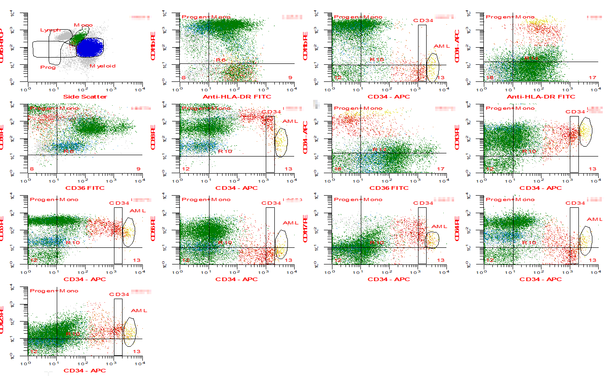

Analysis/Conclusions: The ∆:™ Flow Cytometry findings reveal: 7.4% lymphocytes, 6.1% monocytes, 81% myeloid forms (all stages of maturation), 0.05% lymphoblasts, and 0.04% abnormal myeloid progenitor cells consistent with residual AML. Cell enrichment, by Fluorescent Activated Cell Sorting (FACS), of CD34 positive cells that included the abnormal cell population was followed by FISH (FACS-FISH).
FACS-FISH

FISH (fluorescence in situ hybridization) Result: Abnormal Monosomy 7
Interphase FISH (fluorescence in situ hybridization) was performed using the D7S522/CEP 7 probe set to assess the CD34+ flow cytometric sorted cell population for the presence of monosomy 7. During the analysis of 200 interphase cells with the D7S522/CEP 7 probe set showed a 1R1G pattern (see image) in 25% of the CD34+ cells examined, consistent with monosomy 7.

Best for Your Patient – Best for You

