HematoLogics
3161 Elliott Avenue, Suite 200, Seattle, WA 98121 Phone (800) 860-0934 Fax: (206) 223-5550 www.hematologics.com

Pioneer in Monitoring Response to Therapy (MRD) using ∆N:™ (Difference from Normal) Flow Cytometry
- Hematologics validated ∆N:™ offers superior sensitivity and specificity. As low as 0.02% detection within a 24-hour turn-around time.

- HematoLogics ∆N:™ has been adopted by the Children’s Oncology Group (COG) for MRD detection in AML replacing morphology as the gold standard

Eidenschink Brodersen L, Gerbing RB, Alonzo TA, Pardo L, Alonzo TA, Paine D, et al. “Morphologic remission status is limited compared to ΔN flow cytometry: A Children’s Oncology Group AAML0531 report. Blood Advances 2020 Oct; 4(20):5050-5061.

- ∆N:™ detects phenotypic evolution that can be missed by the widely used Leukemia Associated Immunophenotype (LAIP) approach
Zeijlemaker W. et al. “Tumor heterogeneity makes AML a ‘moving target’ for detection of residual disease.” Cytometry B Clin Cytom 2014 Jan; 86(1):3-14.

Loken M.R. “Residual Disease in AML, a target that can move in more than one direction.” Cytometry B Clin Cytom. 2014 Jan; 86(1):15-17.

Grimwade D. et al. “Defining Minimal Residual Disease in acute myeloid leukemia: which platforms are ready for ‘prime time’?” Blood. 2014 Nov 27; 124(23):3345-3355.

Eidenschink Brodersen L, Gerbing RB, Alonzo TA, Pardo L, Alonzo TA, Paine D, et al. “Morphologic remission status is limited compared to ΔN flow cytometry: A Children’s Oncology Group AAML0531 report. Blood Advances 2020 Oct; 4(20):5050-5061.

- ∆N:™ has been validated in four clinical trials spanning over 15 years and greater than 2,500 patients
Loken M.R. et al. “Residual Disease detected by multidimensional flow cytometry signifies high relapse risk in patients with de novo acute myeloid leukemia: a report from the Children’s Oncology Group.” Blood. 2012 Aug 23; 120(8):1581-1588.

- ∆N:™ has been validated in Pediatric and Adult Specimens
Loken M.R. et al. “Consistent Quantitative Gene Product Expression: #3. Invariance with Age.” Cytometry A. 2016 Nov; 89(11):997- 1000.

Loken M.R. et al. “Consistent Quantitative Gene Product Expression: #2. Antigen intensities on bone marrow cells are invariant between individuals.” Cytometry A. 2016 Nov; 89(11):987-996.

- HematoLogics is the only commercial laboratory using Clinical Cell Sorting for
molecular confirmation of neoplastic populations
Zehentner B.K. et al. “Minimal Disease Detection and Confirmation in Hematologic Malignancies: Combining Cell sorting with Clonality Profiling” 2006 Clin Chem 52(3):430-437.
Best for Your Patient - Best for You

The same poor outcome is seen when abnormal blasts are >25% as when residual disease levels are as low as 0.1%. (See Below)
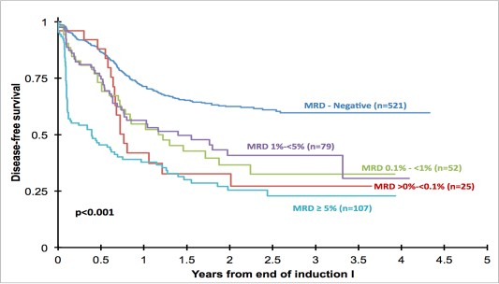

A portion of this work was presented in poster format, at the 54th Annual Meeting of the American Society of Hematology, Atlanta, GA, December 8-11, 2012.

On the other hand, patients may present with >15% normal blasts while recovering from chemotherapy. Only HematoLogics can confidently distinguish residual disease leukemia from regenerating marrows by ∆N:™ Flow Cytometry.

HematoLogics offers a complete test menu including ∆N:™ Flow Cytometry*, Molecular Genetics* (most complete RT-PCR menu for quantitative monitoring), Cytogenetics*, FISH*, Next Generation Sequencing, SNP/CGH microarray, Morphology, Integrated Testing and Reporting.

*COG Certified

