HematoLogics, Inc.
3161 Elliott Avenue, Suite 200, Seattle, WA 98121 Phone (800) 860-0934 Fax: (206) 223-5550 www.hematologics.com
Case Study: Diagnosis of MDS
This sample case highlights a patient with blasts <1%, pretreated for lung cancer that now has a high risk MDS (FCSS 4)
This is a case demonstrating the clinical utility of combining ∆N:™ (Difference from Normal) Myeloid Flow Cytometry and cytogenetic testing to identify the cause of pancytopenia. A XX-year-old patient with a clinical history of pancytopenia and an upper gastrointestinal bleed had been treated for lung and esophageal cancer. A bone marrow aspirate specimen was submitted for restaging.

Flow Findings: Analysis of the myeloid populations reveals hypogranularity with an asynchronous left shift in myeloid antigen expression. Monocytes also are asynchronous in antigen expression. In addition, a small population of myeloid cells expresses CD56. The myeloblast population expresses HLA-DR, heterogeneous CD34, CD13, CD33 and CD117. The lymphoblasts appear normal with the expected antigen expression. The mature lymphoid cells are heterogeneous with 22% polyclonal B lymphoid cells, 3.6% NK cells and 65% T cells. All these mature lymphoid cells express normal antigenic patterns. Total non-erythroid cells expressing CD34 are present at 0.3%.
Analysis/Conclusions: The ∆N:™ flow cytometric findings reveal abnormal myeloid antigen expression (0.3%), with no evidence of increased myeloblasts, abnormal lymphoblasts, or lymphoma in the bone marrow. The MDS flow score for this patient is 4, myelomonocytic dyspoiesis in a high-risk category.
Cytogenetics: Karyotyping studies show abnormal karyotype with 12/20 cells showing t(17;20).

Diagnosis: Consistent with refractory anemia with multilineage dysplasia (RCMD) with a poor risk factor 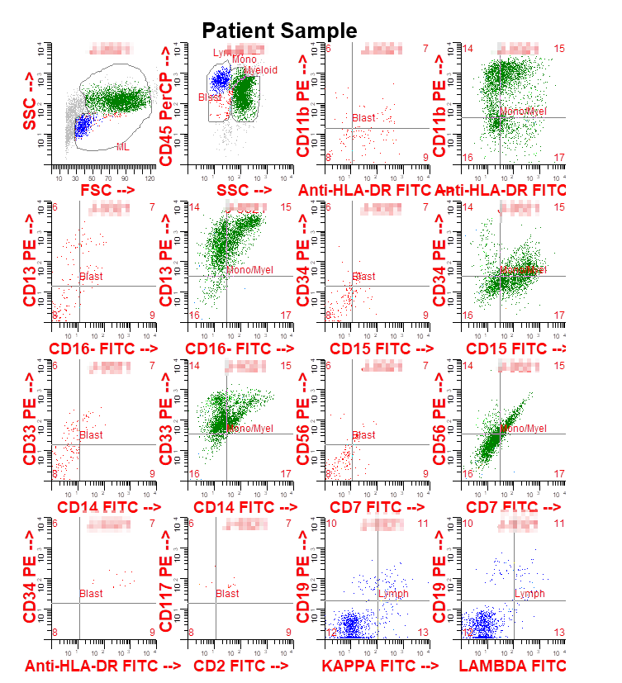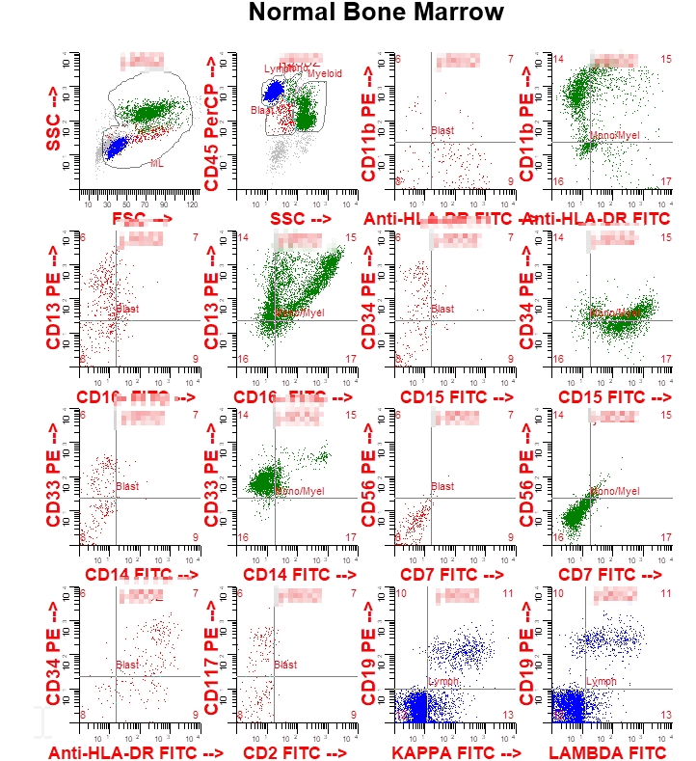

The MDS ∆N:™ Flow Cytometry Score for this patient is a high risk 4
Best for Your Patient – Best for You

MDS Survival Rates Compared to Flow Cytometric Scoring System (FCSS)
The Flow Cytometric Score was determined as published previously (Wells, et al, Blood, 2003). Survival rates were compared in three groups, with Mild/Normal (FCSS 1) patients having the best survival rates; Moderate (FCSS 2 or 3) showing a drop in survival; and Severe (FCSS 4 or higher) exhibited very poor survival rates, even when blasts are <5% (traditionally considered low risk). Patients with a high FCSS and <5% blasts had decreased survival, with an average of 6 months.
∆N:™ Myeloid Flow Cytometry using the FCSS can add prognostic data to help make treatment decisions. Patients at higher risk for transfusion dependency can also be identified.
ChuS-C,et al.Flow cytometric scoring system as a diagnostic and prognostic tool in myelodysplastic syndromes. Leuk Res(2011),doi:10.1016/j.leukres.2011.02.016

