HematoLogics, Inc.
3161 Elliott Avenue, Suite 200, Seattle, WA 98121 Phone (800) 860-0934 Fax: (206) 223-5550 www.hematologics.com

Fluorescent Activated Cell Sorting (FACS) Combined with FISH (FACS – FISH) Improves Specificity, Sensitivity and Diagnostic Confidence in AML Testing

FACS-FISH in AML Improves Diagnostic Confidence and Sensitivity

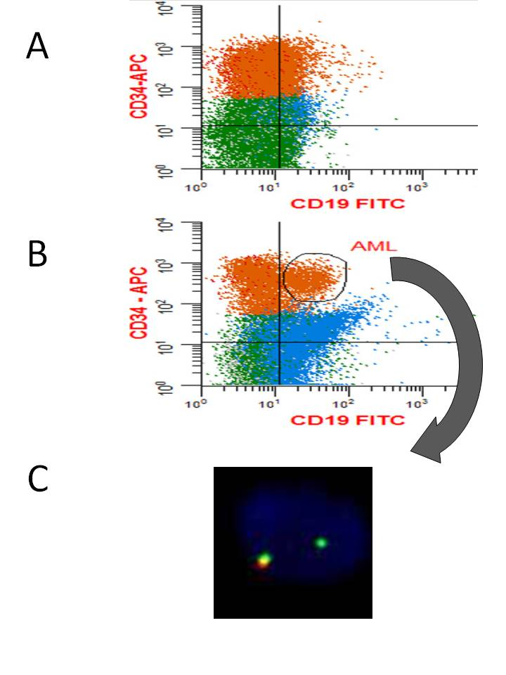
∆N:™ (Difference from Normal) Myeloid Flow Cytometry identifies a 0.5% MRD Post-treatment which the Leukemia Associated Immunophenotype (LAIP) method can miss.
Diagnostic immunophenotype shows AML with t(11;19)
MLL/KM2TA/11q23 BAP FISH
0R1G1F MLL rearrangement with 3’ deletion
FACS
FISH

Best for Your Patient - Best for You
FACS-FISH in AML Improves MRD Testing Specificity and Correlates ∆N:™ (Difference from Normal) Flow Cytometry to Molecular Findings

- Diagnostic sample shows AML with t(8;11): core binding factor in AML {aka Inv(16)}
- Post treatment for MRD shows no evidence of AML with t(8;11) by ∆N:™ flow cytometry but positive for RUNX1/RUNX1T1
- CD34 cells were sorted by FACS
- RUNX1/RUNX1T1 RQ-PCR positive on MAST cells, not CD34 cells
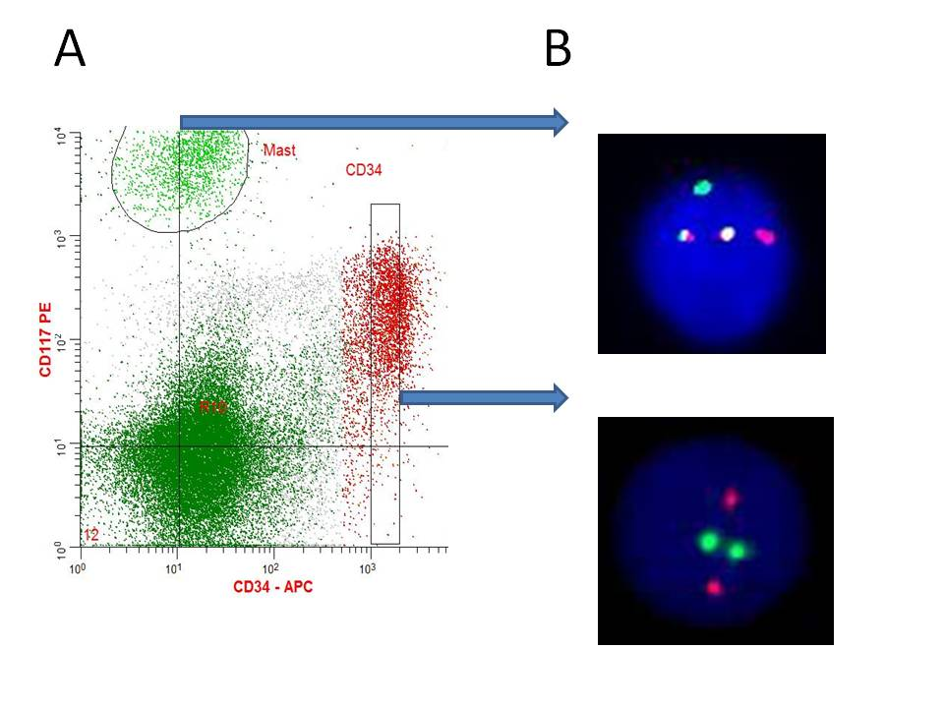
∆N:™Flow Cytometry
FISH
FACS
RUNX1/RUNX1T1
2R2G
No rearrangement
RUNX1/RUNX1T1
aka AML/ETO
1R1G2F
t(8;21)

