HematoLogics, Inc.
3161 Elliott Avenue, Suite 200, Seattle, WA 98121 Phone: (800) 860‐0934 Fax: (206) 223‐5550 www.hematologics.com

CD33 SNP Assay Can Predict Response to Gemtuzumab Ozogamicin (GO; MylotargTM) Treatment in AML Patients

MylotargTM has been FDA approved for treatment of AML.

Recent studies have shown that approximately 49% of CD33 positive AML patients will NOT respond to MylotargTM.

- A single nucleotide polymorphism can predict response to MylotargTM .

- HematoLogics has developed a molecular diagnostic test to identify patients who will benefit from treatment with MylotargTM.

- CD33 SNP sequencing analysis will determine if the patient has a T-allele (non-responsive to MylotargTM) or a CC-genotype (responsive to MylotargTM).

Sample Molecular Analysis Report
Results/Conclusions: The specimen tested positive for the presence of a C>T (p.A14V) single nucleotide polymorphism (rs12459419) in Exon 2 of CD33 (genotype CT)
Presence of the T-alleles has recently been correlated to resistance to treatment with Gemtuzumab Ozogamicin (GO; MylotargTM).1
The presence of CD33 non-synonymous coding single nucleotide polymorphism rs12459419 (T-allele; CT/ TT genotype) has been associated with expression of alternatively spliced variant of CD33. In contrast, a CC-genotype for CD33 rs12459419 has been correlated with full length expression of CD33. Patients with a CC-genotype may benefit from addition of Gemtuzumab Ozogamicin (MylotargTM) to chemotherapy. 1-4

References:

1 Lamba, JK.et al. Leukemia 2009. 23:402-404
2.Mortland L et al. Clincial Cancer Res 2013 19:1620-1627 3.Pollard JA et al Blood 2012 119:3705-3711
4. Burnett AK et al J Clin Oncol. 2011;29:369-377

Best for Your Patient—Best for You

Homozygous C>C allele allows the use of Gemtuzumab Ozogamicin (GO;
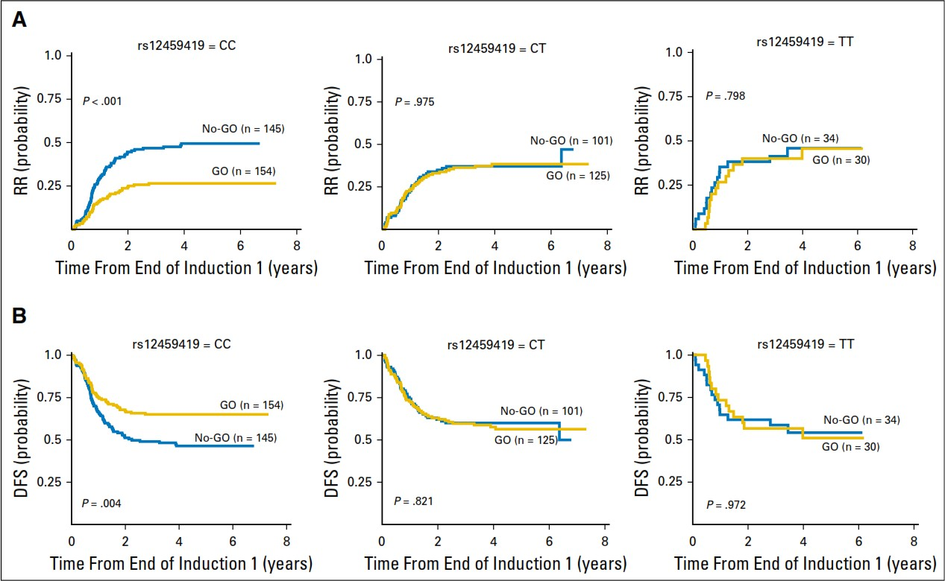
MylotargTM) as an option for treatment of AML, while heterozygous C>T or homozygous T>T patients predicts lack of response.
Lamba, J. K., Chauhan, L., Shin, M., Loken, M. R., Pollard, J. A., Wang, Y. C., S. Meshinchi, S. (2017). CD33 splicing polymorphism determines gemtuzumab ozogamicin response in de novo acute myeloid leukemia: Report from randomized phase III children’s oncology group trial AAML0531. Journal of Clinical Oncology, 35(23), 674-2682. DOI: 10.1200/JCO.2016.71.251

